Cyanogenic glycosides

Cyanogenic glycosides are a group of nitrile‐containing plant secondary compounds that yields cyanide (cyanogenesis) following their enzymatic breakdown. Cyanogenic glycosides occur in at least 2000 plant species, of which a number of species are used as food. They are amino‐acid‐derived constituents of plants produced as secondary metabolites. Despite great deal of structural diversity in cyanogenic glycosides, almost all of them are believed to be derived from only six different amino acids L‐valine, L‐isoleucine, L‐leucine, L‐phenylalanine, or L‐tyrosine, and cyclopentenyl‐glycine (a nonprotein amino acid). Although cyanoglycosides contain nitrogen their structure is that of O- and not N-glycosides. The sugar portion of the molecule may be a monosaccharide or a disaccharide, such as gentiobiose (two units of glucose) or vicianose (arabinose and glucose moieties). If disaccharide, enzymes present in the plant may bring about hydrolysis in two stages as in the case of amygdalin Cyanogenic glycosides play pivotal roles in organization of chemical defence system in plants and in plant‐insect interactions.
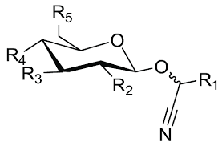

Structures of cyanogenic glycosides found in major edible plants

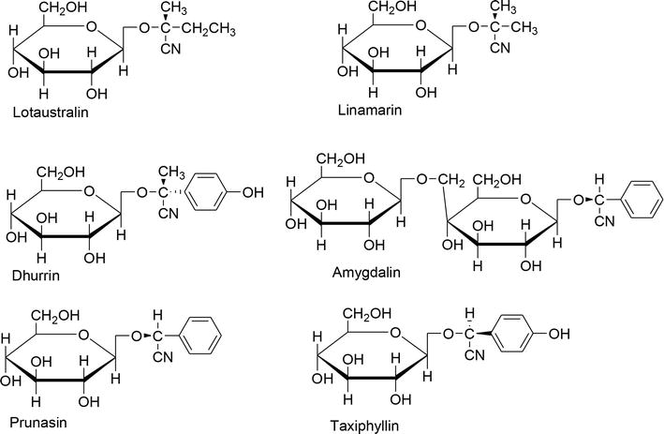

Cyanogenic glycosides are common in certain families such as the Fabaceae, Rosaceae, Leguminosae, Linaceae, and Compositae, and identification of their constituents is a useful tool for informative taxonomic markers . There are approximately 25 known cyanogenic glycosides and these are generally found in the edible parts of plants, such as apples, apricots, cherries, peaches, plums, quinces, particularly in the seed of such fruits. The chemicals are also found in almonds, stone fruit, pome fruit, cassava, bamboo shoots, linseed/flaxseed, lima beans, coco yam, chick peas, cashews, and kirsch. Other food products that may contain cyanogenic glycosides include some food ingredients with flavoring properties such as ground almonds powder or paste, marzipan, stone fruit, and alcoholic drinks made from stone fruits. These foods therefore represent potential sources of hydrogen cyanide. Generally, the level of cyanogenic glycosides produced is dependent upon the age and the variety of the plant, as well as environmental factors.

Cyanogenic glycosides in major edible plants.

Species | Family | Vegetative part | Source of HCN
Cassava (Manihot esculenta) | Euphorbiaceae | Leaves, tuber peel, and parenchyma | Linamarin  Lotaustralin
Sorghum (Sorghum bicolor) | Poaceae | Fruits (seeds), shoot tips, and leaves | Dhurrin
Cocoyam (Colocasia esculenta and Xanthosoma sagittifolium) | Araceae | Leaves and roots | Dhurrin
Bamboo (Bambusa vulgaris) | Poaceae | Stem and sprouts | Taxiphyllin
Apple (Malus domestica) | Rosaceae | Seeds and fruits | Amygdalin
Apricot (Prunus armeniaca) | Rosaceae | Kernels | Amygdalin  Prunasin

Cyanogenic glycosides are formed in the cytoplasm but stored in the central vacuole. Since cyanogenic glycosides are polar substances they do not diffuse across biomembranes, such as the tonoplast by simple diffusion. Although not yet demonstrated experimentally, a carrier-mediated transport system or vesicle fusion might exist to facilitate an exchange from cytoplasm into the vacuole.
Cyanogenic glycosides are stored in cell vacuoles of the plant tissue, separating them from their hydrolysing enzymes, specific β-1,6-glucosidases and hydroxynitrile lyases. In case of destruction of the plant tissue, the β-glucosidases come in contact with cyanogenic glycosides, resulting in the enzymatic cleavage of the carbohydrate moiety. The free α-hydroxynitrile can then either be enzymatically cleaved or spontaneously dissociate into a ketone or aldehyde and hydrocyanic acid. In case of a missing or inactivated plant β-1,6-glycosidases, a release of HCN may also be caused by enzymatic activity of the bacterial flora of the gastrointestinal tract. Mammalian tissues themselves, however, do not contain significant amounts of specific β-glucosidase, and after parenteral application, cyanogenic glycosides are much less toxic compared with an application via the oral route.

Functions of Cyanogenic glycosides
Their ability to liberate toxic levels of hydrogen cyanide (HCN) principally offers an immediate chemical defense response to herbivores and pathogens causing damage of the plant tissue, if their glycoside content is high enough. Cyanogenic glycosides have gained additional functionalities as transporters of nitrogen, and operation of an endogenous turnover pathway may enable plants to withdraw the nitrogen and glucose deposited in cyanogenic glycosides for use in primary metabolism
Besides their role as respiratory toxins, cyanogenic glycosides as such or as the corresponding aldehyde or ketone are often feeding deterrents. Additionally they can serve as mobile nitrogen storage compounds in seeds of several plants (e.g. in Prunus and in Lima bean Phaseolus lunatus), a property already noted for non-protein amino acids or some alkaloids.

Physical and Chemical Properties
Cyanoglycosides are white crystalline odorless substances with a very bitter taste. They are soluble in hot water and ethanol, and insoluble in organic solvents (chloroform, dichloroethane). They are easily cleaved by specific enzymes (amygdalase, prunase, linamarase).

Extraction and Research Methods
In order to identify cyanogenic glycosides the plant material flask with sufficient water to moisten. In the neck of the flask a suitably impregnated strip of filter-paper is well broken and placed in a small is suspended by a cork. The paper may be treated in either of the following ways to give a color reaction with free hydrocyanic acid: either sodium picrate (yellow), which is converted to sodium isopurpurate (brick-red),or a freshly prepared solution of guaiacum resin in absolute alcohol, which is allowed to dry on the paper and treated with very dilute copper sulphate solution. The latter test paper turns blue with prussic acid. If the enzymes usually present in the material have not been destroyed or inactivated, the hydrolysis takes place within about an hour provided that the flask is kept in a warm place. More rapid hydrolysis will result if a little dilute sulfuric acid is added, and the flask gently heated. The intensity of the color produced with sodium picrate paper can be used for semiquantitative evaluations. More sensitive methods, including the direct determination of individual glycosides by gas-liquid chromatography, are now available.

Toxicity of Cyanogenic glycosides
Cyanogenic glycoside is not toxic on its own. However, when cell structures of plant are disrupted, cyanogenic glycoside will be brought together with the corresponding β‐glucosidase enzyme. Hydrolysis of cyanogenic glycosides usually occurs when cyanogenic plants are chewed by herbivores or when the plants are disintegrated during processes, such as grinding, pounding or in the presence of water for example during soaking or fermentation. Hydrolysis is accomplished by the β‐glucosidase, producing sugars and a cyanohydrin that spontaneously decomposes to HCN and a ketone or aldehyde. Different kinds of cyanogenic glycosides may be found in different cyanogenic food plants, for example, taxiphyllin in bamboo shoots, linamarin in cassava.

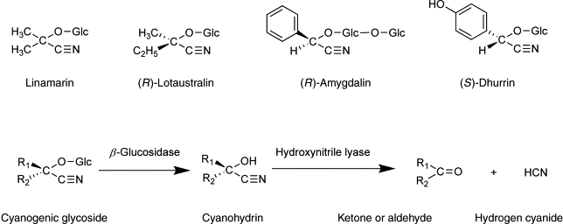

The toxicity of cyanogenic glycosides and their derivatives is dependent on the release of hydrogen cyanide. Toxicity may result in acute cyanide poisoning and has also been implicated in the etiology of several chronic diseases . Cyanide is one of the most potent, rapidly acting, poisons known. Cyanides inhibit the oxidative processes of cells causing them to die very quickly. Because the body rapidly detoxifies cyanide, an adult human can withstand 50-60 ppm for an hour without serious consequences. However, exposure to concentrations of 200-500 ppm for 30 minutes is usually fatal. Aside from death, acute cyanide toxicity at small doses can cause headache, tightness in throat and chest, and muscle weakness. The effects of chronic (long-term) exposure to cyanide are less well known.
Cyanide toxicity can occur in animal including humans at doses between 0.5 and 3.5 mg HCN per kilogram body weight. Symptoms of cyanide toxicity in humans have been reported to include vomiting, stomach ache, diarrhea, convulsion, and in severe cases death. Children are particularly at risk because of their smaller body size.
The toxicity of cyanogenic glycosides is associated with their ability to be hydrolyzed either spontaneously or in the presence of enzyme to produce cyanide as end products of their hydrolysis. Thus, toxic levels of cyanogenic glycosides are estimated in terms of the quantity of free cyanide generated following hydrolysis. This makes it difficult to estimate total cyanogenic glycosides in diet. Hence, levels of amygdalin (the most common cyanogenic glycosides in fruits) reported in literature are inconsistent. Although the level of cyanide up to 10ppm was reported by World Health Organization (WHO) to be safe for cassava flour. Lack of quantitative toxicological test and epidemiological information makes it difficult to establish safe level of cyanogenic glycosides intake in many foods.

The toxic cyanogenic glycosides

(b) Biosynthesis and function of cyanogenic glycosides
Cyanogenic glycosides are derived from l-amino acids (Fig. A) and biosynthesis seems to be catalyzed by a multienzyme complex (Fig. B). Dhurrin biosynthesis was achieved in a microsomal membrane preparation and seemed to be a channeled process. In the first step, the amino group of l-amino acids is hydroxylated by a l-amino acid N-monooxygenase. Upon oxidative decarboxylation, the N-hydroxy-l-amino acid is converted into an aldoxime. The step from aldoxime to nitrile is catalyzed by an aldoxime dehydratase. The nitrile is then hydroxylated at the C2-position by a nitrile monooxygenase to yield the key intermediate 2-hydroxynitrile (or cyanohydrin). Glucosyltransferase forms the β-glucoside using activated glucose, i.e. UDP-glucose.
In case of emergency, i.e. when plants are wounded by herbivores or other organisms, the cellular compartmentation breaks down and cyanogenic glycosides come into contact with an active β-glucosidase of broad specificity, which hydrolyzes them to yield 2-hydroxynitrile (cyanohydrin) (Figs A and B). 2-Hydroxynitrile is further cleaved into the corresponding aldehyde or ketone and HCN by a hydroxynitrile lyase. In cyanolipids, the fatty acid is hydrolyzed by an esterase to 2-hydroxynitrile to yield the corresponding aldehyde and HCN (Fig. B).

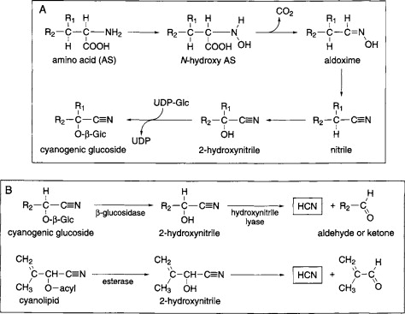

Biosynthesis of cyanogenic glycosides
In plants, cyanogenic glycosides are derivatives of five amino acids (valine, isoleucine, leucine, oophenylalanine, and tyrosine) and the non-proteinogenic amino acid, cyclopentenyl glycine. Linamarin and lotaustralin are derived from valine, isoleucine, and leucine, while dhurrin is derived from tyrosine. Amygdalin and prunasin are derived from phenylalanine. The biosynthesis of various cyanogenic glycosides in different plants has been described, and the most extensively reported are dhurrin in sorghum and linamarin in cassava.

The generic biosynthetic pathway for the production of cyanogenic glycosides from amino acids.
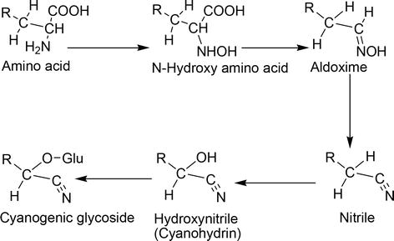

The biosynthetic pathway for cyanogenic glycosides from its precursor amino acid [13].
The first two steps of biosynthetic production of cyanogenic glycoside are catalyzed by a cytochrome P450 enzyme through two successive N-hydroxylations of the amino group of the parent amino acid. The α-hydroxynitrile (cyanohydrin) is then generated following the decarboxylation and dehydration of aldoxime and nitrile, respectively [14]. The final step that produces cyanogenic glycoside involves glycosylation of the cyanohydrin moiety, and the process is catalyzed by UDPG-glycosyltransferase [10].

Many of cyanogenic glucosides, but not all, are derived from nitril of mandalic acid. Aglycones of cyanogenic glycosides are derived solely from nitrogen intermediates. The biosynthesis of prulaurasin has been studied in the leaves of Prunus laurocerasus. The biosynthesis of linamarin and prunosin is described in

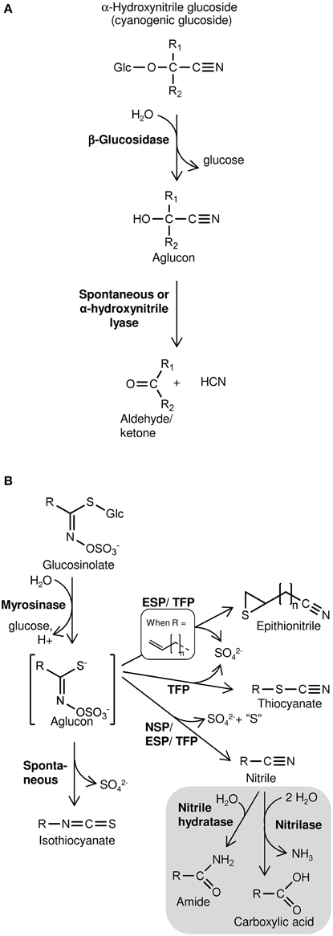
Figure 1. Schematic overview of hydrolysis of cyanogenic glucosides (A) and glucosinolates (B) and subsequent product formation. (A) Cyanogenic glucosides (α-hydroxynitrile glucosides) release HCN following hydrolysis of the β-glucosidic bond. In β- and γ-hydroxynitrile glucosides the CN-group is bound to another carbon than the O-glucosidic linkage. Consequently, hydrolysis of the β-glucosidic bond of these compounds does not result in HCN release. (B) Glucosinolate product formation is dependent on the variable side chain (R) structure and presence of specifier proteins (NSP, nitrile specifier protein; ESP, epithiospecifier protein; TFP, thiocyanate-forming protein). Gray section: Glucosinolate-derived nitriles may be metkabolized in vitro by nitrilases possessing nitrilase activity and/or nitrile hydratase activity. Nitrilase activity was suggested to mobilize nitrogen following glucosinolate turnover in vivo

Cyanogenesis

Cyanogenesis is the ability of some plants to synthesize cyanogenic glycosides to form hydrogen cyanide via cyanohydrin intermediate. The hydrolysis of the cyanogenic glycosides is accomplished by the β-glucosidase enzymes, which facilitate the cleavage of the carbohydrate moiety of the cyanogenic glycoside to yield corresponding cyanohydrins which further decompose to release hydrogen cyanide and an aldehyde or ketone as illustrated in Figure 2. The final step that produces the toxic compound, HCN, is catalyzed by hydroxynitrile lyase enzyme, which is widespread in cyanogenic plants.

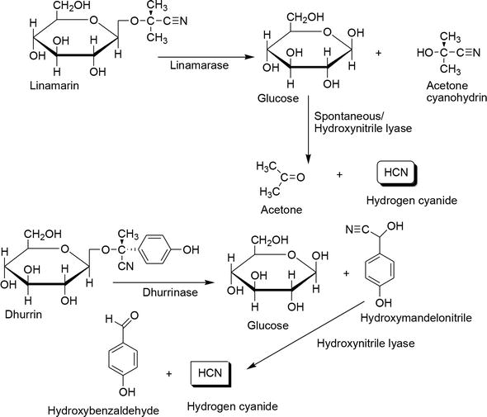
Enzymatic hydrolysis of cyanogenic compounds linamarin and dhurrin.
Determination of cyanogenic glycosides
There are two methods for qualification and determination of cyanogenic glycosides, and they are direct and indirect ones. The direct method uses cyanogenic glycosides as the target molecules, while the latter addresses the released HCN after hydrolysis.
High-Performance Liquid Chromatography (HPLC) has been the mainstay for the direct determination of cyanogenic glycosides. A column with porous graphitic carbon and also C-18 ones are commonly used, altogether with various mobile phase systems: methanol/water (9:1), water/methanol (80:20), or gradient of water and acetonitrile. Ultrahigh-Pressure Liquid Chromatography (UPHLC) and Gas-Liquid Chromatography (GLC) analysis were also successfully developed for the determination of these compounds. Another direct determination of cyanogenic glycosides utilized 1H nuclear magnetic resonance (NMR), whıch was found to be a very suitable tool to perform analysis of cyanogenic glycosides in flax seeds. Micellar Capillary Electrophoresis (MEKC) was also developed for the separation of amygdalin, prunasin, neoamygdalin, and sambunigrin from seeds of peach and apple. Excellent and rapid separation of those four cyanogenic glycosides, as well as the detection of prunasin and amygdalin in peach seeds, could be obtained with this method.
The most common indirect determination of cyanogenic glycosides is the Guignard sodium picrate test. It detects HCN released from fresh plant material when the glycosides are hydrolyzed. Toluene is added to the samples for damaging the cuticle and permitting the passage of HCN to the outside of the cells. The HCN then reacts with sodium picrate absorbed by the paper and turns its color from yellow to red. Chemosensors are gradually developed for the identification of HCN released from hydrolyzed cyanogenic glycoside. The hydrolytically released HCN from fresh cassava reacts with the aquacyanocobyrinic acid (ACCA, a derivative of vitamin B12), producing dicyanocobyrinic acid (DCCA). The presence of this reaction is marked by a color change from orange to violet. This reaction takes place within seconds and does not interfere with different anions or other biological molecules of the plant sample.
Extraction and isolation of cyanogenyc glycosides
Since of cyanogenic glycosides are considered as anti-nutrients, in the food science area, extraction of plants associated with these compounds are mainly for optimizing the composition of their beneficial compounds and minimizing cyanogenic glycosides in the obtained extract. Aside from the content of phenolic compounds and their antioxidant activity, the utilization of water or 60 % ethanol for the extraction of flaxseed significantly affected the content of cyanogenic glucosides in their extract. These compounds were much lower in aqueous extract than in ethanolic extract.
However, in phytochemistry, a natural approach is used to isolate cyanogenic glycosides. In general, they are isolated from plant materials by grinding, with subsequent or concomitant extraction with solvents such as ethanol, methanol, water, or mixtures thereof. The mixture is heated to boiling for several minutes to deactivate enzymes. The slurry is filtered and centrifuged to remove particulate material. The extraction can be performed at -80oC to avoid problems of enzymatic and possible thermal, followed by filtration at room temperature. The solvent is then removed under vacuum and the remained extract is re-dissolved in water. Any precipitate which may occur at this stage should be removed by filtration. The aqueous solution should be extracted with light petroleum or CHCl3 to remove lipids. The extract can be treated with lead acetate, followed by hydrogen sulfide to remove undesirable acidic components. Phenolic compounds can be removed by chromatography on the polyvinylpyrrolidone column, while many acidic, essential, and ionic impurities can be eliminated with mixed bed ion exchange resins or a combination of acidic and basic ion exchange resins. The isolation can be performed with continuous liquid-liquid extraction using ethyl acetate, paper chromatography using various solvent systems, or column chromatography on cellulose, silica gel, kieselgel, or florist stationary phase.
Biological Action and Application.
Cyanogenic glycosides have the sedative and analgesic action. But their use is limited by their toxicity. One of their hydrolysis products is hydrogen cyanide, which halts cellular respiration by inhibiting the enzyme in mitochondria called cytochrome C oxidase. Exposure to hydrogencyanide can be rapidly fatal. It has systemic effects, particularly affecting those organ systems most sensitive to low oxygen levels: the central nervous system, the cardiovascular system, and the pulmonary system. Cyanoglycosides have a similar action, but much less expressed.

ISOTHIOCYANATES
Isothiocyanates comprise the chemical group ⁻N=C=S, formed by substituting sulfur for oxygen in the isocyanate group.
Allyl isothiocyanate is an organosulfur compound with the formula CH₂CHCH₂NCS found in mustard oil and is responsible for its pungency. It is used for amino acid sequencing in Edman degradation. This colorless oil is responsible for the pungent taste of mustard, horseradish, and wasabi. It is slightly soluble in water, but well soluble in most organic solvents. Hydrolysis of allyl isothiocyanate gives allyl amine.
Allyl isothiocyanate comes from the seeds of black mustard (Brassica nigra) or brown Indian mustard (Brassica juncea). When these mustard seeds are broken, the enzyme myrosinase is released and acts on a glucosinolate known as sinigrin to give allyl isothiocyanate.
Allyl isothiocyanate serves the plant as a defense against herbivores; since it is harmful to the plant itself, it is stored in the harmless form of the glucosinolate, separate from the myrosinase enzyme. When an animal chews the plant, the allyl isothiocyanate is released, repelling the animal.
Allyl isothiocyanate can be liberated by dry distillation of the seeds. The product obtained in this fashion is known as volatile oil of mustard and is usually around 92% pure. It is used principally as a flavoring agent in foods. Synthetic allyl isothiocyanate is used as an insecticide, bacteriocide, and nematocide, and is used in certain cases for crop protection.
Thioglycosides or glucosinolates. - derivatives of cyclic forms of thio-sugars, in the SH-group whose hydrogen atom is substituted aglycone. For example, a glycoside, sinigrin, which is characteristic for plants Fam. cruciferous (cabbage): mustard and g.chernaya). Thioglycosides or glucosinolates are particularly common in cruciferous and are found in such of its representatives, as mustard, horseradish, turnip, radish, etc. The plants contained in the form of salts with alkali metals, usually with potassium.
Over a century ago sinigrin and sinalbin were isolated in a crystalline form from black and white mustards. These and similar glycosides have since been isolated from many plants, particularly those used as condiments or in folk medicine; they have the general structure:

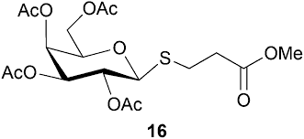
Many such glycosides, with a variety of side-chains, including indolyl, are now known; all contakin the B-D-1-glucopyranosyl residue. They have been found only in dicotyledonous plants and are particularly abundant in the families Brassicaceae, Capparidacene, and Resedaceae with sporakdic occurrences in the Euphorbiaceae, Tovariace- ae, Moringaceae, Tropaeolaceae, and Caricaceae families. The enzyme myrosinase has a similar wide distribution. Thioglycosides (glucosinolates) are one of the most characteristic groups of natural compound of the Brassicaceae family.
The plants contain the enzyme myrosinase, which, in the presence of water, cleaves off the glucose group from a glucosinolate. The remaining molecule then quickly converts to an isothiocyanate, a nitrile, or a thiocyanate these are the active substances that serve as defence for the plant.
Therefore, glucosinolates are also called mustard oil glycosides. The standard product of the reaction isk isothiocyanate (mustard oil);the other two products mainly occur in the presence of specialized plant proteins that alter the outcome of the reaction. To prevent damage to the plant itself myrosinase and glucosinolates are stored in separate compartments of the cell and come together only or mainly under conditions of physical injury.

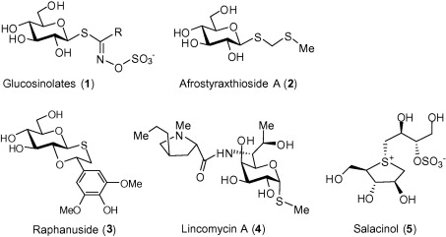
Biosynthesis of Thioglycosides
Biosynthesis of the glucosinolates of the relevant Brassicaceae takes place principally in the fruit wall with the subsequent translocation to the seed. About 120 different glucosinolates are known to occur naturally in plants. They are synthesized from certain amino acids, the so-called aliphatic glucosinolates derived from mainly methionine, but also alanine, leucine or valine. (Most glucosinolates kare actually derived from the chain -elongated homologs of these amino acids, eg. Glucophanin derived from dihomomethionine, which is methionine chain-elongated twice). Aromatic glucosinolates include indolic glucosinolates, such as glucobrassicin, derived from tryptophan and others from phenylalanine, its chain-elongated homolog homophenyl-alanine, and sinalbin derived from tyrosine.
It was proven that suitable amino acids are converted to thioglycosides by the plant. With sinigrin, the thioglucoside found in horse-radish leaves and in black mustard seeds, the most effective precursor of the carbon chain appears to be homomethionine rather than allyglycine, which inspection of the sinigrin structure might suggest. Homomethionine arises by chain lengthening of methionine with acetate by a mechanism that is similar to formation of leucine from valine. Althoughk the sulfur atom on the thioglycoside moiety may be introduced by feeding with methionine, it was shown that sulfur of cysteine is a more efficient precursor. The sulfur of the bisulphite portion of the molecule is more readily introduced from inorganic sources. Some incorporations consistent with the envisaged pathway for sinigrin are illustrated in Fig. 7.3.

Physical and Chemical Properties
Thioglycosides are crystalline substances, which are hardly hydrolyzed under the action of acids or alkali, but are easily hydrolyzed byenzymes at the presence of water. Thioglycoside aglycones are volatile odorous liquids with a bitter taste. They are soluble in warm water andalcohols, insoluble in polar solvents (ether, chloroform, petroleum ether etc.).
Thioglycosides are identified by gas-liquid, paper and thin-layer chromatography. Under the action of Wagner's reagent with ferric (III) chloride they give blue spots on TLC.
The quantitative determination of isothiocyanates is performed by the titration method (mustard oil reacts with ammoniac, the product of this reaction forms silver sulfide with silver nitrate, the latter is titrated by ammonium cyanate). Thiocyanates are determined by spectrophotometry after the reaction with ferric (III) nitrate.
Biological Action and Application.
Medicinal plants contain glucosinolates (eg, mustard), has long been used in medicine as a means of annoying and distracting. But as irritating to have no native glucosinolates and the products of their transformation, the safety of raw enzymes break down these compounds is a prerequisite for the manifestation of specific pharmacological activity.
Isothiocyanates, such as phenethyl isothiocyanate (PEITC) and sulforaphane, have been shown to inhibit carcinogenesis and tumorigenesis and as such are useful chemopreventive agents against the development and proliferation of cancers.
The phytoestrogen action of indole substance, indole-3- carbinol, which is produced by the breakdown of the glucosinolate glucobrassicin, is revealed in the prophylaxis of hormone-depending breast and prostate cancer, and improvement of systemic lupus erythematosus symptoms.

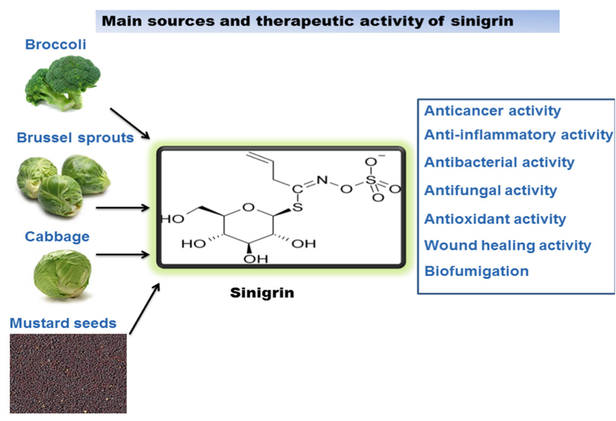

Sinapis juncea L.

SEEDS mustard - SEMEN SINAPIS JUNCEAE Brassica juncea (L.) Czern. Mustard - Brassica juncea (L.) Czern. (syn. Family Cabbage – Brassicaceae
Biological describtion. Annual herbaceous plant. Root sheath, penetrates to a depth of 2-3 meters. Stem erect, branched at the base, glabrous, 50-150 cm tall . Leaves: lower leaves petiolate , large, lyre-pinnately incised, rarely almost entire or curly, feathery, green, pubescent or subglabrous; top - sedentary or are short, one-piece upper, glaucous.
Flowers bisexual, small, early blooming along with buds were collected in racemose or corymbose inflorescences ; petals are golden-yellow, limb is not so gradually tapering to claw like colza, long nail. Sepals almost horizontal. The ovary contains 12-20 ovules. Pedicel in fruit 8-17 mm in length, rejected at an angle of 45 °. Blooms in April - May. The fruit - lumpy, thin, elongated, cylindrical pod with a thin, subulate beak constituting ¼ lengths pod, 7-12 mm long, and a clear medium rib and lateral veins clearly visible intertwined than rape or colza, length 2,5-5 cm, are opened.
Seeds diameter 1-1,3 mm, cellular, reddish-brown or dark brown, rarely yellow. Weight of 1000 seeds - 2-4 grams. The fruits ripen in August.
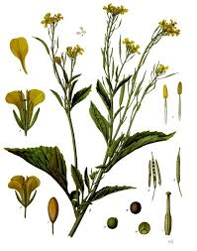
Distribution and ecology. In the wild mustard is found in the steppes of southern Siberia , in Central Asia , as well as in Mongolia and northern China. Rather difficult to understand where it's native, and where wild. Cultivated in India , China , Indochina , Asia Minor , North Africa , the countries of Europe . India is by far the largest center of cultivation of this crop. In other cultures, is considered weedy plant. Cold-resistant plant. Mustard drought-resistant , has low soil .

Chemical composition. The seeds contain 0,5-2,89% essential oil , which consists of allyl (40%) and krotonilgorchichnoe (50%) of oil, and traces of carbon disulfide and dimethyl sulfide ; 20-49 (25-30 ^{[4]} )% high- fat mustard oil , which is composed of erucic , oleic , linoleic , peanut , lagnotserinovaya , behenic , palmitic , linoleic and dioksistearinovaya acid. In seeds contain a glycoside sinigrin and enzyme mirozin . Enzyme mirozin in the water sector, and at temperature cleaves glycosides on glucose , potassium sulfite, and ether-mustard oil . Sareptskoy mustard leaves contain 0.0002% carotene , 0.056% ascorbic acid , to 0,2% calcium , and 0.0002% iron .
Good properties of the oil obtained by cold pressing During hot pressing oil goes into mustard essential oil and a glycoside sinigrin, which has a pungent smell and taste bad. Butter to taste better sunflower , on the quality of higher oil of white mustard , but is easier to go rancid.
Application. Mustard is one of the most important oilseed crops . A good bee plant . Mustard oil used in cooking, baking, confectionery, canned goods, soap, textile, farmachevticheskoy and perfumery industry, as well as technical. Defatted meal of seeds used for preparation of table mustard.
Application in Medicine. Powder of defatted mustard seed has a warming effect and is used to prepare mustard plasters , they are used in medicine as a warming agent and distracting, causing a rush of blood and deepening your breath when inflammation of the lungs , neuralgia , for the reflex effects on the function of blood circulation , and hypertensive crises , threatening stroke , angina . In protracted chronic rhinitis good sprinkle of dry mustard powder in your socks and wear them at night. Mustard not only stimulates the appetite , but also greatly enhances the release of gastric juice Still , Pythagoras believed that mustard enhances memory. In folk medicine, mustard seeds, used as a means of stimulating the activity of the gastrointestinal tract , as a laxative , emetic for malaria , calm. Ingestion of seeds and mustard powder in pure form or diluted milk helps in case of poisoning by any poisons.

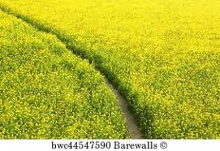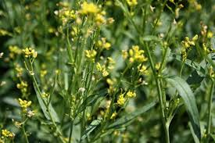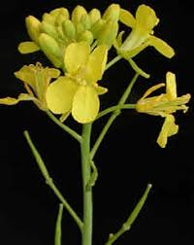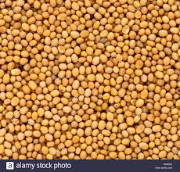
Amygdalus communis
Amygdalus communis L. var. dulcis Borkh ex DC. - Prunus amygdalus (L.) Batsch var. dulcis -Sweet Almond, Jordan-, Valencia-, or Malaga Almonds, Greek Nuts; Amygdalus communis L. var. amara Ludwig ex DC. - Prunusamygdalus (L.) Batsch var. Amara - Bitter Almond;
Family – Rosaceae.
Part Used.—Oleum Amygdalarum consists of the fixed oil, obtained by expression from the seeds of Amygdalus communis L. var. dulcis Borkh ex DC., or Amygdalus communis L. var. amara Ludwig ex DC., Rosaceae.
Area of distribution. Native to the Middle East and South Asia
Habitat.—The tree is indigenous to Western Asia (Asia Minor) and is extensively cultivated in many regions. The oil is mainly produced from almonds grown in the countries bordering the Mediterranean.
Plant.—The plant is of medium height, seldom reaching 12 m. It is a tree or shrub with mildly red - tinged branches, thorny in its wild form but not in the cultivated form. The leaves have a 1.2 to 1.5 cm long, glandular petiole and glabrous, oblong – lanceolate - acuminate or serrate, tough, glossy, dark green blades. The flowers are very short - petioled in pairs and appear before the leaves. The petals are 19 to 20 mm long, pale pink to whitish with dark veins. The fruit is oblong-ovoid, compressed. 3.5 to 4.6 cm long by 2.5 to 3 cm wide, gray-green, velvet-downy and pubescent. The nut shell is yellow, hard, compressed, broad- and sharp-edged, punctuate externally with irregular grooves, smooth and glossy inside and thick- or thin-skinned. The seed is cinnamon brown, flattened, and 2 cm long by 1.2 to 1.5 cm wide. When ripe the portion of the pericarp external to the endocarp splits into two halves and falls off the stone or "shell."
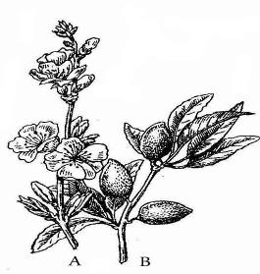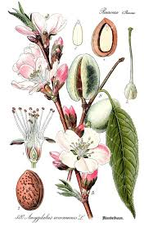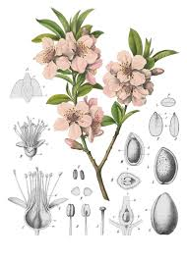

Fig. Amygdalus communis. A –Branch, bearing leaves and flowers; B - Branch, bearing fruit
MPM Description.—The seeds are entire, ovate or oblong-lanceolate, exalbuminous, up to 30 mm. in length, up to 17 mm in breadth and 9 mm or less in thickness; spermoderm thin, yellowish- to reddish-brown, coarsely longitudinally furrowed, easily removed on soaking the seed in water; embryo straight, whitish, consisting of two large plano-convex cotyledons, a short conical hypocotyl, and a short plumule at the pointed end of the seed; odour slight; taste bland and sweet. Upon bruising and triturating in water, a milk-white emulsion is produced which is devoid of the odour of benzaldehyde or hydrocyanic acid.
Expressed Almond Oil (Oleum Amygdalae expressum), or Sweet Almond Oil is a fixed oil obtained from the kernels of varieties of Prunus amygdalus (L.) Batsch. It is a clear, pale straw coloured or colourless oily liquid with a bland taste; sp. gr. 0.910 to 0.915 at 25°C.
According to the EP., Refined almond oil is the fatty oil from the ripe seeds ofPrunus dulcis (Miller) D.A. Webb var. dulcis or Prunus dulcis (Miller) D.A. Webb var. amara (D.C.) Buchheim or a mixture of both varieties by cold expression. It is then refined. A suitable antioxidant may be added.
Refined almond oil is a pale yellow, clear liquid, slightly soluble in alcohol, miscible with light petroleum. It solidifies at about - 18 °C and has a relative density of about 0.916. Acid value: not more than 0.5, determined on 5.0 g. Peroxide value: not more than 5.0. Unsaponifiable matter: not more than 0.7 per cent, determined on 5.0 g.
According to the EP., Virgin almond oil is a fatty oil obtained by cold expression from the ripe seeds of Prunus dulcis (Miller) D.A. Webb var. dulcis or Prunus dulcis (Miller) D.A. Webb var. amara (D.C.) Buchheim or a mixture of both varieties.
Virgin almond oil is a yellow, clear liquid; slightly soluble in ethanol (96 per cent), miscible with light petroleum. It solidifies at about − 18 °C and its relative density is about 0.916. Acid value: maximum 2.0, determined on 5.0 g. Peroxide value: maximum 15.0. Unsaponifiable matter: maximum 0.9 per cent, determined on 5.0 g.
Constituents.—Bitter almond: Fatty oil (non-dehydrating, 38 to 60%): chief fatty acids oleic acid (77%) and linoleic acid (17 to 20%). Cyanogenic glycosides: amygdalin, 0.2 to 8.5% (corresponding to 12 to 500 mg prussic acid per 100 gm). Mucilages (3 to 3%): arabinogalactans. Proteic substances (25 to 35%).
Sweet almond: Fatty oil (non-dehydrating, 43 to 57%): chief fatty acids oleic acid (77%) and linoleic acid (17 to 20%). Mucilages (3 to 4%): arabinogalactans. Proteic substances (20 to 25%).
Pharmacological Action. Uses.—Sweet Almonds have a demulcent and a mild laxative effect. Sweet Almonds are used topically in skin care and liniments. The volatile almond oils are used as flavouring agents.
Application. The bitter almond water (contains 0.1% of hydrogen cyanide) may be used in mixtures as sedative and analgesic. In homeopathy, it is used for treating headaches.
Contraindications. Bitter almonds are not recommended in pregnant or breastfeeding women.
Drug interactions. In theory, bitter almond may increase the amount of drowsiness caused by some drugs. Examples include benzodiazepines, barbiturates, narcotics, some antidepressants, and alcohol. Caution is advised while driving or operating machinery. Avoid the use of alcohol as almond oil may cause a toxic reaction (nausea, vomiting, increased breathing, sweating) when taken with alcohol. Amygdalin, bitter almond, and laetrile may also interact with analgesics, central nervous system depressants, agents that suppress or stimulate the immune system, and agents that are excreted through the kidneys.
Side Effects. Allergies to almonds are common and to severe reactions, including throat swelling have lead breathing. If being allergic to other nuts, that interferes with almondsit is probably best to avoid
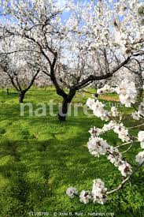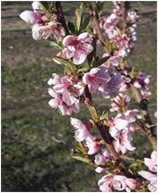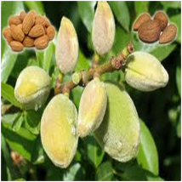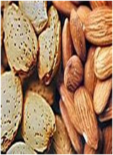

Onion - Állium cépa Family Onion – Alliaceae Part used - Onion Bulbs

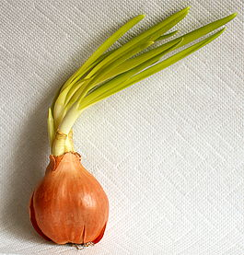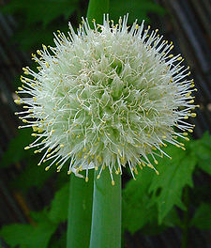

Botanical description
A perennial plant (cultivated - biannual ). Bulb up to 15 cm in diameter, scarious. Outer scales are dry, yellow, rarely purple or white interior - the fleshy, white, green or violet, are on a shorter stem , called the Donets. On the Donets in the axils of the scales are succulent buds , giving rise to daughter bulbs, which form a "nest" of a few bulbs. The leaves are tubular, bluish-green. Flower arrow to 1,5 m tall, hollow, inflated, many-flowered ends umbrella inflorescence . The flowers on long stalks . Perianth greenish-white, up to 1 cm in diameter, six leaves, stamens 6; pestle with top trehgnezdnoy ovary . Sometimes in the inflorescence but flowers form small bulblets.
The fruit - a box containing six seeds . Seeds black, triangular, wrinkled, small. Flowering in June-July. The fruits ripen in August.

Distribution. The most popular of all cultivated species has onion (Allium cepa L). Other species are cultivated on a smaller scale Onions are grown everywhere since ancient times.

Harvesting. Harvesting onions begin after a mass lodging pen. Bulbs dried on beds 5-6 days sorted.

Chemical composition
The bulbs contain 8-14% of sugars ( fructose , sucrose , maltose , polysaccharide inulin ), proteins (1,5-2%), vitamins ( ascorbic acid ), flavonoid quercetin , enzymes , saponins , mineral salts of potassium , phosphorus , iron , etc ., volatile oil. In green leaves of onion also contains sugar, proteins, ascorbic acid. In the bulbs and leaves of a volatile oil , which gives them a peculiar odor and pungent taste, sulfur compounds, iodine , organic acids ( malic and citric ), mucus , pectin , glycosides . Onions contain merkaptometilpentanol - a substance that actively connects peroxynitrite.

Application in Medicine
Onions stimulates okthe secretion of digestive juices, has a diuretic and a sedative effect . Volatile onion determine bactericidal and anthelminthic properties of the plant. In medicine, known since the time of Hippocrates . Medicinal properties of onion recognized by all nations. The Romans believed that the strength and courage of soldiers increase in the use of a bow, so it was a military ration. When Hippocrates prescribed onions patients with rheumatism , gout , as well as obesity . The famous Persian physician and scientist Ibn Sina (Avicenna) in the beginning of XI wrote about the onion: "Edible onions are particularly helpful in poor water from the harm, if you throw in her treatment of onions is one of the means destroying her scent ... Onion juice is useful in contaminated wounds, lubricate eyes squeezed juice of onion with honey is useful from walleye ... Onion Juice help for a sore throat. Edible onion because of its bitterness strengthens a weak stomach and stimulates appetite. " In the East there was a saying: "Look in your arms - held every disease." Onion is a good vitamin medium, especially recommended in winter-spring period, but used all year round. A significant amount of mineral salts in the bow when it is used in food promotes the normalization of water-salt metabolism in the body, and the peculiar smell and sharp taste of appetite. Onions are widely used in modern medicine. From onion obtained preparations " Allilchep "and" Allilglitser . "Allilchep, rendering antimicrobial action , stimulates the motility of the intestine , is used as in diarrhea and colitis, with a tendency to constipation , and intestinal atony , atherosclerosis and sclerotic form of hypertension "Allilglitser" is recommended for the treatment of Trichomonas colpitis in the form of tampons. Onion is a popular cosmetic product in many countries around the world. Juice, onion recommend oiling the scalp with seborrhea , female pattern baldness , to strengthen the hair roots. In this case, your hair becomes silky, soft and shiny and your skin does not flake, does not form dandruff. From bulbar juice fade freckles , receiving a bow inward, as well as onion mask (from a mixture of onion gruel with honey) prevents the appearance of wrinkles, facial skin becomes fresh.

Garlic Family Onion – Alliaceae Part used - Garlic Bulbs (cloves)

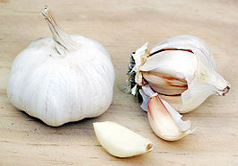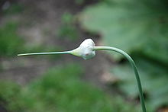
Garlic - biannual , herbaceous plant , the form genus onion family Onion (Alliaceae). Hot vegetable culture in many nations around the world, because it has a sharp taste and characteristic odor associated with the group of organic compounds- sulphides . Widely used in medicine due to the antiviral action. Garlic cloves are used as planting material used for food (raw or cooked as a seasoning). Leaves , arrows, and flower stalks are also edible and are used mainly in young plants. Thus not only eat the roots of plants and a thin protective peel cloves. All parts of the plant have a characteristic garlic smell
Botanical describtion
Leaves flat, linear, lanceolate, elongated, centimeter-wide, tapered to a close, smooth-edged , the length is 30-100 cm Each subsequent sheet grows from inside the previous one, thereby creating a false stem , more durable than the onions . Peduncle up to 1.5 m, to bloom at the end of the spiraling and ends inflorescence in the form of an umbrella . Inflorescence - a simple ball-shaped umbrella, consisting of a sterile white and whitish-pink flowers, air-proliferating bulbils bulbochek and densely cover (wrapper) . The fruit - capsule , seed garlic does not form. The root system is fibrous. Bulb complex, consisting of 2-50 cloves, each covered with a tough leathery scales. Bulbs can be white, yellow, dark purple, pink and purple.
Distribution and ecology
Homeland is the South-East Asia , where the plant is cultivated since the Neolithic . In the wild form is found almost everywhere. Ancient cultivated plant , cultivated forms are divided into ordinary and arrows (nestrelkuyuschiesya).Distinguish between spring and winter garlic. Winter Garlic prefers loamy soil, and the spring grows well in medium-and light loamy soils .

Composition
In the follicles contained 35-42% solids, including 6,0-7,9% protein , 7,0-28 mg% vitamin C (in the leaves - up to 80 mg% ), 0.5% sugars, 20 - 27% of polysaccharides . Taste and smell of garlic due to the presence of essential oil (0,23-0,74%), which contains allicin and other organic compounds sulfide group ( volatile ).

Other components:
- Allicin
- Sitosterol
- Caffeic acid
- Chlorogenic acid
- Diallildisulfid
- Ferulic acid (3-hydroxy-4-methoxy-fenilpropenovaya acid)
- Geraniol
- Kaempferol
- Linalool
- Oleanolic acid
- Coumaric acid
- Floroglyutsin
- Phytic acid
- Quercetin
- Ruthin
- Alliltsistein
- Saponins
- Stigmasterol

Application in Medicine
In medical use the drug from the bulbs of garlic - garlic tincture and alcohol extract ( allilsat ) that enhance motor and secretory function of the gastrointestinal tract, and other drugs . Garlic - a broad spectrum antibiotic. It kills very large numbers of various bacteria. Studies have shown that raw garlic in their properties are not comparable to, and something even better than a well-known drug tetracycline. But remember that the funds based on garlic, we can not take a long time in large quantities, as the garlic begins to suppress the intestinal flora and cause irritation. Assign inside for the suppression of putrefaction and fermentation in the gut (intestinal atony in and colitis ), as well as hypertension and atherosclerosis.
Proven antiviral effect of garlic , in particular, garlic to a certain extent helps to prevent influenza . Supposed immunostimulatory and anticancer effects of garlic preparations.

Contraindications
There is no consensus about whether garlic destroys the microflora in the intestine . Onions and garlic is toxic for cats and dogs.
When kidney disease, gallstones , anemia, stomach ulcer or intestinal should be extremely cautious in the use of garlic.
Food use
Because of its sharp taste of garlic are widely used worldwide as a seasoning or ingredient. It is an important element in many dishes in different regions, such as in East and South Asia , the Middle East and North Africa , garlic - an indispensable attribute of Mediterranean cuisine . In Korea and Japan, garlic kvass at high temperatures, the resulting product, called "black garlic (see Black garlic (English)), has a sweet and luscious to the taste, now you can buy in the United States, UK and Australia.

Almonds - Amygdalus communis L. Synonyms Amygdalus dulcis Mill. Prunus amygdalus Batsch Prunus communis ( L. ) Arcang. Family Rosaceae Part used - the seeds of almonds – semen amygdali

Botanical description

Shrub (rarely a small tree ), 4-6 m tall, very branched. Stems of two types: elongated vegetative and generative shortened. Leaves lanceolate. Flowers solitary, up to 2.5 cm in diameter, with white or pale pink petals , numerous stamens and one pistil , composed of bokalchatoy gamophyllous cups and pink or red corolla . The fruit - dry velvety-pubescent oval odnokostyanka, dry pericarp during ripening can be easily separated from the bone . Bone ("nuts") is the same shape as the fruits are covered with small dimples, sometimes with grooves, 2,5-3,5 cm long.

Distribution. The primary focus of the formation is in the Near East and adjacent areas, including the Mediterranean and Central Asia In these areas, culture almonds originated many centuries before our era. Currently, the largest plantings of almonds are in the Mediterranean, in China , USA (State of California ), Central Asia, Kopetdag and Western Tien-Shan , Crimea and the Caucasus . Almonds grow on rocky and gravelly slopes at an altitude of 800 to 1600 m above sea level (almonds Bukhara reaches 2500 m), prefers rich in calcium soil. It grows in small groups of 3-4 individuals, separated from one another by 5-7 meters

Chemical composition

Nucleus seed culture of sweet almonds contain fatty oil (40-60%), proteins (30%), mucus , vitamins , colorants - carotene , carotenoids , lycopene and others, as well as essential oil (0,5-0 , 8%), indicating their smell, and traces of the glycoside amygdalin . Oil derived from non-peeled seeds of sweet almonds, contains small amounts of linolenic and myristic acids , which are absent in the oils obtained from treated seeds. Seeds of wild bitter almonds are toxic, due to the presence of glycoside amygdalin, which is released by cleavage of hydrocyanic acid , benzaldehyde and glucose . Whole almond kernels do not smell. Being cut acquire specific almond flavor.

Uses

Almonds can be planted as an ornamental plant soil-protective . Bitter almonds are not edible, are receiving fat oil. Oil, refined from amygdalin, used for cooking the best varieties of soap. Oil cake is poisonous, in the past because it was prepared medical bitter almond water designated as a sedative , tonic and analgesic funds. He was removed from the essential oil for fragrance perfumes.

Application in Medicine

From the seeds of almonds cold or hot pressing of an oil. Almond oil is used in the food, cosmetic and pharmaceutical industries. It serves as a solvent of camphor injection, the basis for therapeutic and cosmetic ointments (softens skin and has anti-inflammatory effect ), he was appointed interior, especially the children as a laxative , and in the form of emulsions - how enveloping and emollient . Sweet almond kernels used in folk medicine for anemia , diabetes , asthma , insomnia , migraine , as antitussive , and convulsions ; almond oil can be used inside as a sedative for heart disease , as anti-inflammatory for pneumonia and diseases of the throat , and flatulence , as a means increases appetite; externally - from bedsores.

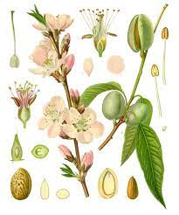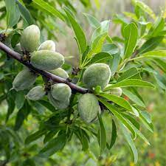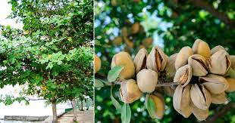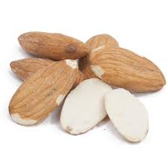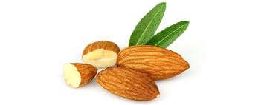

ELDER FLOWERS
SAMBUCI FLORES
Black Elder - Sambucus nigra L.,
Fam. Caprifoliaceae.
Synonym(s): Elderberry, European Elder, European Elderberry, European Black Elderberry, Common Elder, Elder Bush.
Various species: American elder or common elder (Sambucus canadensis), antelope brush (Sambucus tridentata), blue elderberry (Sambucus coerulea), danewort (Sambucus ebulus), dwarf elder (Sambucus ebulus), red-fruit elder (Sambucus pubens, Sambucus racemosa), and Sambucus formosana.

Botanical description

It is a deciduous shrub or small tree growing to 4-6m(rarely to 10 m) tall. The bark, light gray when young, changes to a coarse gray outer bark with lengthwise furrowing. The leaves are
arranged in opposite pairs, 10-30 cm long, pinnate with five to seven(rarely nine) leaflets, the leaflets 5-12 cm long and 3-5 cm broad, with large cora serrated margin. The hermaphrodite flowers are borne in ymbs 10-25 cm in diameter in midsummer, the individual flowers are white, 5-6 mm in diameter, with five petals; they are pollinated by flies.
The fruit is a dark purple to black berry 3-5 mm in diameter.
Area of distribution. Native to most of Europe.
Constituents. The bark, leaves, seeds and raw/unripe fruit contain the cyanogenic glycoside sambunigrin, which is potentially toxic.
The dark color of elderberry fruit occurs from its rich phenolic content, particularly from anthocyanins. Components of the elderberry plant, including its fruit, contain diverse phytochemicals, such as alkaloids, lectins, and cyanogenic glycosides, which may be toxic if consumed raw. Consumption of berries, leaves, bark or stems, if not properly prepared, may cause nausea, vomiting, and severe diarrhea. Elderberry plant constituents or products should not be consumed during pregnancy or by people with allergies or gastrointestinal diseases. Elderberry products may cause adverse effects when used with prescription drugs.
Application. Stembark, leaves, flowers, fruits, root extracts are used to treat bronchitis,
cough, upper respiratory cold infections, fever. The flowers can be used to make a herbal tea as
a remedy for inflammation caused by colds and fever. Combination products containing elder and other herbs have been reported to have beneficial effects when used with antibiotics to treat sinus infections.
Contraindications. Elder cannot be recommended during pregnancy or breast-feeding based on a theoretical risk of birth defects or spontaneous abortion.
Drug interactions. The flavonoid quercetin, which is found in elder, has been reported to inhibit xanthine oxidase, and may affect caffeine and theophylline levels. Elder may increase the effects and possible adverse effects of some cancer chemotherapies. Based on the preliminary research the increased benefits may be seen when elder is used in combination with antibiotics and decongestants, such as oxymetazoline. Elder flowers may possess anti-inflammatory properties and may add to the effects of some drugs that also decrease inflammation. Elder may possess
diuretic (urine producing) effects, and should be used cautiously with herbs that may increase urination, such as artichoke, dandelion, or horsetail. Elder may possess laxative effects, and should be used cautiously with herbs that may also have laxative effects, such as alder buckthorn, or psyllium. The plant may lower blood sugar levels. Caution is advised when using herbs or supplements that may also lower blood sugar, such as burdock, maitake mushroom, or milk thistle. Blood glucose levels may require monitoring, and doses may need adjustment. Increased effects may be seen when elder is used in combination with other antioxidants, such
as vitamin C or flavonoids like quercetin.
Side effects. Elderberry products should be used under the direction of a qualified healthcare provider because of the possible risk of cyanide toxicity, especially from the elder bark, root, or leaves. There are reports of gastrointestinal distress, diarrhea, vomiting, abdominal cramps, and weakness after drinking elderberry juice made from crushed leaves, stems and uncooked elderberries. Notably, the berries must be cooked to prevent nausea or cyanide toxicity. Allergies are possible from fresh elder stems and may include rash, skin irritation, or difficulty in breathing.
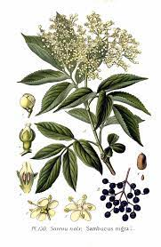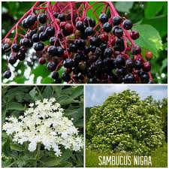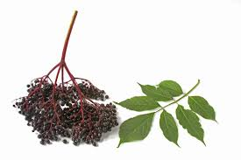

Raphanus sativus- Radish, Cultivated radish-
Family Brassicaceae or Cruciferae
Other Name(s): Black Radish, Black Spanish Radish, Daikon Radish, Long Black Spanish Radish, Moolak, Mooli Beej, Petit Radis, Rábano, Radis, Radis Espagnol, Radis Noir, Radis Noir Espagnol, Radis Rouge, Raphani Sativi Radix, Raphanus sativus, Red Radish, Round Black Spanish Radish, Small Radish, Spanish Radish, Spanish Black Radish, Turnip Radish.
The radish (Raphanus raphanistrum subsp. sativus) is an edible root vegetable of the family Brassicaceae that was domesticated in Asia prior to Roman times.
Radishes are grown and consumed throughout the world, being mostly eaten raw as a crunchy salad vegetable with a pungent flavor. There are numerous varieties, varying in size, flavor, color, and length of time they take to mature

Botanical description: An annual or biennial herb with succulent taproot.
Taproot: Widely variable in colour, shape and size. Red, pink, white, yellow, purple or black externally, white to bright pink internally. Spherical, olive-, spindle- or turnip-shaped, tapering from top or bottom, 2 cm to 1m long and 60 cm in diameter.
Leaves: Lobed, with a larger, rounded, terminal lobe and smaller, paired lower segments. Irregularly toothed.
Flowers: Four white to pink or pale violet petals. Four sepals. Flowers borne on erect, many-flowered inflorescences up to 90 cm tall.
Fruit: A smooth, beaked, fleshy siliqua (fruit divided into two parts by a thin partition and opening by two valves to reveal seeds on central limb).
It is in flower from June to August, and the seeds ripen from July to September.
Constituents.
Radishes owe their sharp flavor to the various chemical compounds produced by the plants,.
Modern pharmaceutical research revealed that the R. sativus. contained a variety of chemical components such as glucosinolates, myrosinase, alkaloids, flavonoids, isothiocyanate, sinapoyl derivatives, volatile oils and fatty acids. The plant contains raphanin, which is antibacterial and antifungal.
The major active compounds in Raphani Semen are alkaloids, glucosinolates, brassinosteroids, and flavonoids.
Application.
The dried ripe seed of Raphanus sativus L., commonly known as radish seed (or Raphani Semen), is used as traditional Chinese medicine (TCM) to treat constipation, chronic tracheitis, and hypertension.

Radishes have long been grown as a food crop, but they also have various medicinal actions. The roots stimulate the appetite and digestion, having a tonic and laxative effect upon the intestines and indirectly stimulating the flow of bile Consuming radish generally results in improved digestion, but some people are sensitive to its acridity and robust action. The plant is used in the treatment of intestinal parasites, though the part of the plant used is not specified. The leaves, seeds and old roots are used in the treatment of asthma and other chest complaints. The juice of the fresh leaves is diuretic and laxative. The seed is carminative, diuretic, expectorant, laxative and stomachic. It is taken internally in the treatment of indigestion, abdominal bloating, wind, acid regurgitation, diarrhoea and bronchitis. The root is antiscorbutic, antispasmodic, astringent, cholagogue, digestive and diuretic. It is crushed and used as a poultice for burns, bruises and smelly feet. Radishes are also an excellent food remedy for stone, gravel and scorbutic conditions. The root is best harvested before the plant flowers. Its use is not recommended if the stomach or intestines are inflamed. The plant contains raphanin, which is antibacterial and antifungal. It inhibits the growth of Staphylococcus aureus, E. coli, streptococci, Pneumococci etc The plant also shows anti-tumour activity.
